**Code:**

package helloworld;

public class helloworld {

public static void main(String[] args){

System.out.println("hello world");

}

}

**Output:**

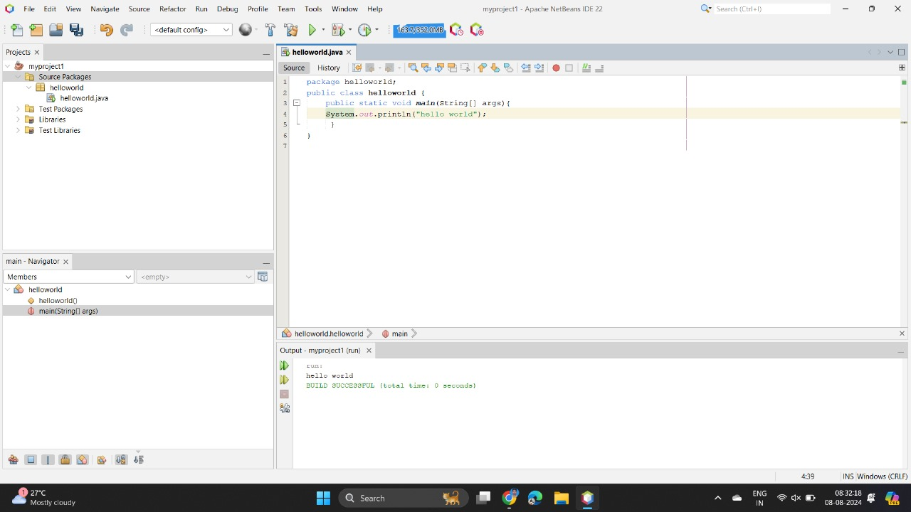

2.

**Code**:

package helloworld;

public class helloworld {

public static void main(String[] args){

system.out.println("hello world");

}

}

**Output:**

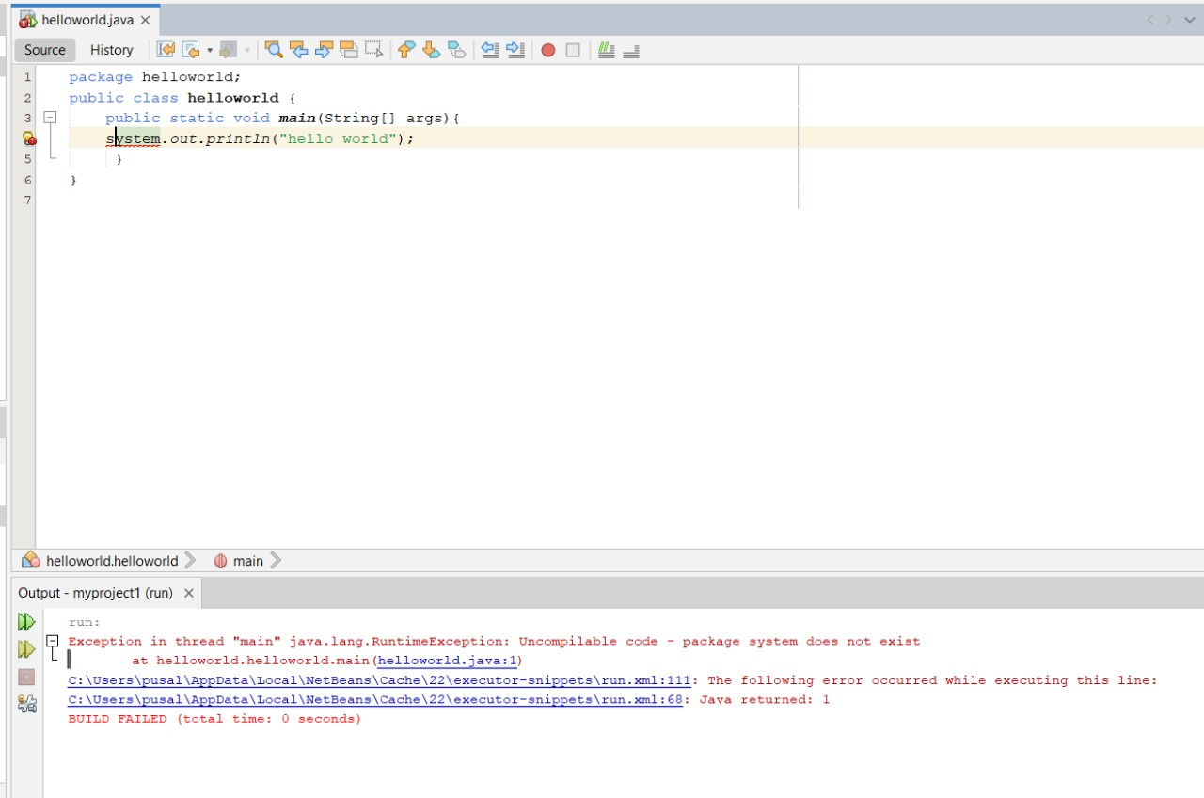

3

**Code**:

package helloworld;

public class helloworld {

public static void main(String[] args){

System.out.println("hello world")

}

}

**Output:**

